A1334-Eur-Iberian-Neolithic-Figure-Anthropomorphic-Conglomerate

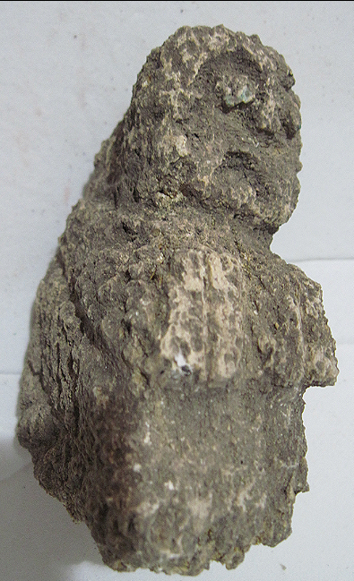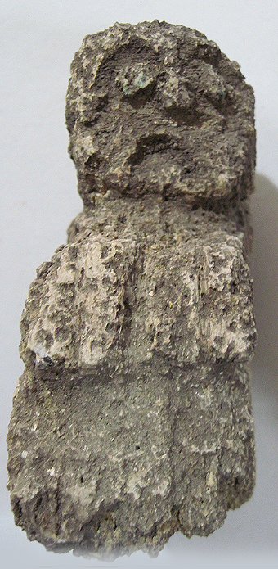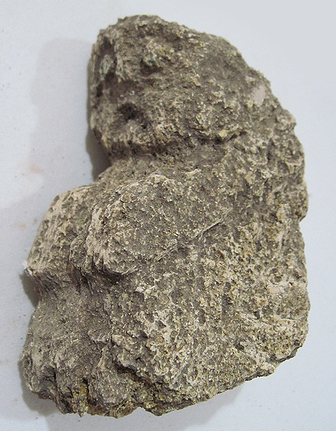

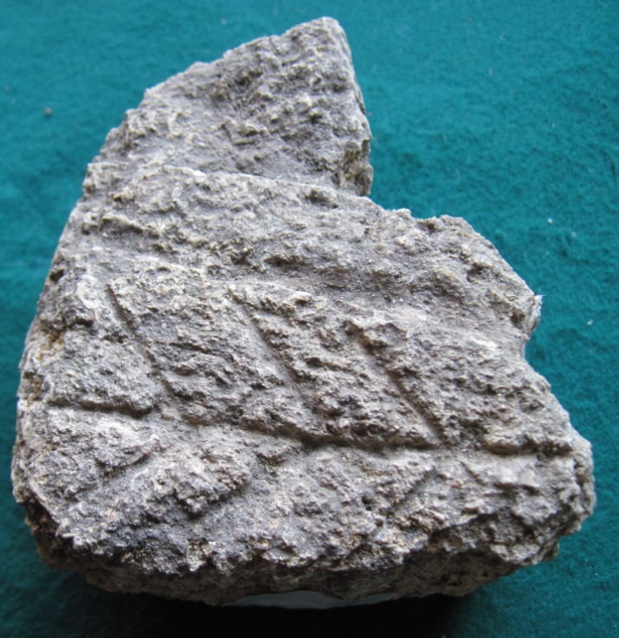 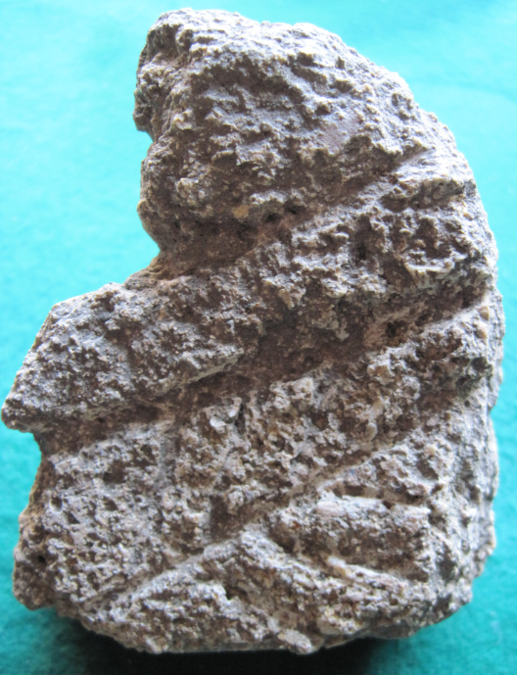

**Figs. 1-3.** Iberian-Neolithic-Figure-Anthropomorphic-Conglomerate.

**Case no.: 3**

**Accession Number: A1334.**

**Formal Label:** Iberian-Neolithic-Figure-Anthropomorphic-Conglomerate.

**Display Description:**

**LC Classification:**

**Date or Time Horizon:**

**Geographical Area:**

**Map, GPS coordinates:**

**Cultural Affiliation:** Iberian Neolithic

**Medium:** conglomerate

**Dimensions:** H 107.02 mm; 4.21 in

**Weight: 465 gm; 1 lb 3.8 oz**

**Condition:**

**Provenance:**

**Discussion:**

**References:**

[**Archaeographic and conceptual advances in interpreting Iberian Neolithisation**](http://www.worldcat.org/title/archaeographic-and-conceptual-advances-in-interpreting-iberian-neolithisation/oclc/442697651&referer=brief_results)

by Luiy Oosterbeek

 Article

Language: English

Publication: Documenta Praehistorica. Poročilo o raziskovanju paleolitika, neolotika in eneolitika v Sloveniji. Neolitske študije = Neolithic studies, 31 (2004), str. 83-87

[**Re-thinking the Mesolithic-Neolithic transition in the Iberian peninsula: a view from the West**](http://www.worldcat.org/title/re-thinking-the-mesolithic-neolithic-transition-in-the-iberian-peninsula-a-view-from-the-west/oclc/441361189&referer=brief_results)

by Luiz Oosterbeek

 Article

Language: English

Publication: Documenta Praehistorica. Poročilo o raziskovanju paleolitika, neolotika in eneolitika v Sloveniji. Neolitske študije = Neolithic studies, [Vol.] 28 (2001), str. 75-84

Database: WorldCat

[**Funerary practices in the Iberian Peninsula from the Mesolithic to the Chalcolithic**](http://www.worldcat.org/title/funerary-practices-in-the-iberian-peninsula-from-the-mesolithic-to-the-chalcolithic/oclc/812876160&referer=brief_results)

by Juan Francisco Gibaja Bao; António Faustino de Carvalho; Philippe Chambon;

 Print book[View all formats and languages »](http://www.worldcat.org/title/funerary-practices-in-the-iberian-peninsula-from-the-mesolithic-to-the-chalcolithic/oclc/812876160/editions?editionsView=true&referer=br)

Language: English

Publisher: Oxford, England : Archaeopress, 2012.

Database: WorldCat

[**The Early Neolithic in the Iberian Peninsula : regional and transregional components = Le Néolithique ancien dans la péninsule Ibérique : les éléments regionaux et transregionaux**](http://www.worldcat.org/title/early-neolithic-in-the-iberian-peninsula-regional-and-transregional-components-le-neolithique-ancien-dans-la-peninsule-iberique-les-elements-regionaux-et-transregionaux/oclc/280380206&referer=brief_results)

by Mariana Diniz; International Union of Prehistoric and Protohistoric Sciences. World Congress

 Print book : Conference publication[View all formats and languages »](http://www.worldcat.org/title/early-neolithic-in-the-iberian-peninsula-regional-and-transregional-components-le-neolithique-ancien-dans-la-peninsule-iberique-les-elements-regionaux-et-transregionaux/oclc/280380206/editions?editionsView=true&referer=br)

Language: English

Publisher: Oxford, England : Archaeopress : Available from Hadrian Books, 2008.

Database: WorldCat

by Joan Bernabeu Aubán

 Article

Language: English

Publication: Documenta Praehistorica. Poročilo o raziskovanju paleolitika, neolotika in eneolitika v Sloveniji. Neolitske študije = Neolithic studies, [Zv.] 26 (1999), str. 101-118

Database: WorldCat